Burzyn

Doresë
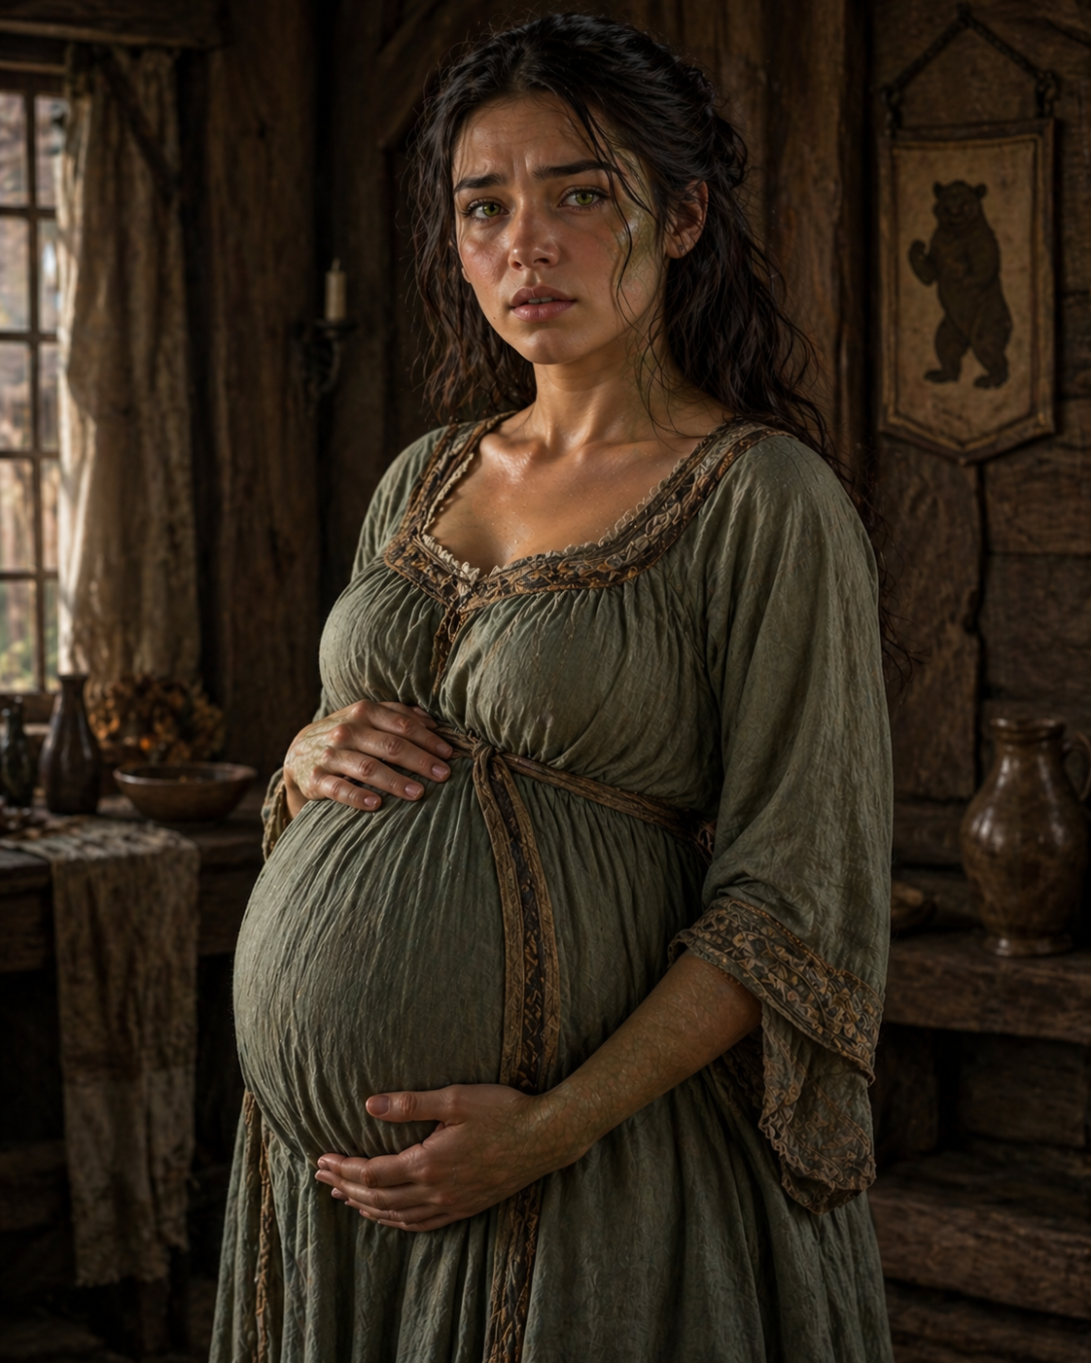
Blaghaid hit on her and her friend Hirilyn, at the Blue Horse in Burzyn. They had an unforgivable night, then Blaghaid left town and Doresë soon found out that she was pregnant. Some strange things manifested themself with her during the pregnancy and she made her way all over to Tashal to find the child father. She is now 16 years old.
Doresë is a young woman on the verge of childbirth, still carrying a softness of youth but marked by quiet strain. She stands protectively, one hand resting over her swollen belly, the other supporting it from beneath.
Her features are gentle but troubled, her gaze slightly unfocused, as if something weighs on her thoughts. There’s a subtle unnaturalness to her—her pupils narrow a touch too much in the light, and her skin has a faint greenish undertone. Along her forearms and near her collar, the texture of her skin hints at something beneath, like the suggestion of scales that haven’t fully surfaced.
She is still human in every obvious way—but something else is beginning to show.

