The Disappearance of Harold

Orcslayer

Hoard of the Dragon Queen
After coming back from the Orclands and getting the praise from Lord Peredur, you find themselves loitering around and doing much of nothing. After awhile, that gets on your nerves and basically on everyone around you as well. You decide to again travel to Sterling to visit the enigmatic sage Nostradamus.
Coming again to his dark tower on the outskirts of the town, and again being hailed by the demon in the door, and again being ushered into Nostradamus extensive and large library/sanctuary/laboratory, by the foul smelling, disappearing manservant. Nostradamus seems pleased that you are back and bids you to follow him. You retell the tale of you adventures in the Orclands and he seems already informed of your success.
He tells you that he has a proposition, that is why some dreams haunted your nights in Durham and made you come back to him. He apologizes for the inconvenience. He tells you that he is part of a realm encompassing organisation called the Society of the Mirror Corridor. He explains that the organization is composed of several mages and scholars in different realms. All residing behind the mirrors of the Corridor of Eiyedor. A nexus of gates leading to different realms across the macro cosmos. He leads you to a very large and strangely colored door, that you think is made of some metal, but you have never seen anything like it. It gleams and pulsate, and sometimes it seems there are glyphs appearing deep inside it that fades back as you concentrate on them.
Nostradamus opens the scintillating door and the room, or corridor, behind it is even more strange than the door. Framed, what looks like mirrors, on each side of the corridor, spaces between two to five meters apart, never opposite one another. The corridor is about eight meters wide and lit by some unknown light source. It stretches as far as you can see in the distance.
Nostradamus bids you to enter and sweeps his robes arm out to encompass the whole corridor with it's portals.
“This is the Corridor of Eiyedor, a nexus point of many portals to other realms. It has, according to my own studies, come into being by the Banestorm event and some strange dimensional magic. It is very powerful and lets a person travelling through a portal to be transformed into another self in the new realm, with juxtaposition, making the person travelling to the new realm to assume or assimilate the correct aspect of oneself in that realm.”
“We in the Society need champions to police these realms, and my proposition to you is to travel to other places, see wondrous things, meet strange and mystical beings and persons. Fight for good, and make a difference in the cosmic playground. Protecting this and other realms from powers or events that might destabilize them or even destroy them. Of course, whatever treasures and other things you find are yours, and besides that fact you will be able to get things from me as an added bonus. What say you?”
Since you are curious and ever interested in seeing new things and battle evil wherever you go, the answer is of course yes.
Nostradamus tells you of some strange events that he has received information of from the realm of Abeir-Toril on the continent of Faerûn.
“My contact there, a monk by the name of Leosin Erlanthar have come back with some information about a cult threatening the whole continent, the Cult of the Dragon. Leosin needs the some of the Society's champions to unravel what the cult is doing and how to stop it, and I thought you would be the perfect agents, the saviors of Lady Bronwyn and the vanquishers of the orchorde of the Orclands. He says that you should go to the small town of Greenest for further information.”
He briefly tells you about the magic of the Corridor of Eiyedor and how it might affect you, for instance, the Aesir god of Gunnar might be converted to a storm god in Faerûn, and that goes for almost everything you know, from knowledge about herbs and plants to places and history. It is very powerful magic.
He says the time is of essence and asks if you are ready to start right away. He gives you ten silver each and comes up to a portal that shows green hills and a road in the distance. The weather is sunny and it seems to be in the middle of the day.
You step through with some hesitation but once you're on the other side you notice that there is no portal on the other side. The question about how you're supposed to get back is on your mind, but there is nothing to it. You're here and you need to fulfill your quest.

Greenest in Flames

23/12-24
You soon comes out to the road you saw in the distance and briefly wonder which way to go. But all have the feeling that following the road eastwards would be a good choice.
You start walking and soon meet some people looking scared and distraught. They get the information that the town of Greenest is under attack. A draconian hoard of creatures and a real huge dragon has attacked the town, they are looting and burning. The day is coming to an end and in the distance you can see smoke in the fading light.
Cresting a hill you look down upon the beleaguered town some kilometers away. In the dim light you can see several small fires, and small dots of people milling around, some seem to be chasing others. Over the town a large shape can be seen flying around. The Dragon. In the fading light it looks slightly blueish.
It seems you come in the midst of an attack. You quickly devise a plan to approach as stealthily as you can, and seek out the keep that seems to be situated on a hill in the middle of the town.
Coming in from the west you sneak about in the fast approaching twilight. The fires have not really spread to the buildings in the town itself but ave set fires to outbuildings and hay bars mostly. The light produced by these fires gives an eerie atmosphere but at least you can see well enough to sneak around.
All of a sudden a wounded and limping man and three children, a little boy and a year or two older daughters, rush out from an alley between two buildings. After them comes a determined woman armed only with a broken spear. She defiantly turns around to stave of what is an attack from pursuing little red scaled dragon-like creatures. Instantly your magically altered memories tells you that these are kobolds. Small craven reptilian humanoids that worship evil dragons as demigods and serve them as minions and toadies. You know they see good in the dark and likes to bully weaker prey with large numbers, they don't usually work alone or on their own initiative. There are eight of them fanning out to take on the valiant woman protecting her family. She taunts the reptilian kobolds and tells her husband to move to the keep with the kids. He does not heed her words.
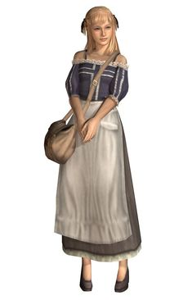Linan
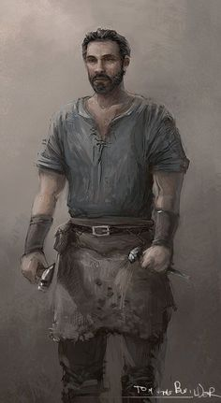Cuth
Kobold
Daisuke charges the group of kobolds without any hesitation, on his way throwing deadly shurikens, taking out one of the assailing kobolds with a hit straight to the face. Gunna shouts a battle roar to make the kobolds change their target which works partially. Five of the eight kobolds targeting the woman now turns towards Gunnar and Daisuke. Gavil throws a spear at on kobold and skewers the monster. Gunnar moves to engage. Thewoman tries to attack one of the kebolds but misses and the kobold misses her as well.
The dim light makes i harder for you to fight but it does not seems to affect the kolbolds the leas. Gavril draws his sword and Gunnar already has his axe ready when he attacks. The fight is short and after Daisuke does some wheel kicks, open hand strikes and other martial arts he kills all of his opponents. The woman has during that time been hit once but not fatally. Gavril chops and dices three kobolds while Gunnar takes care of the rest.
After the last of the kobolds are dealt with you escort the family safely towards the keep. You get there by being stealthy, the woman who introduces herself as Linan carries the small boy, Daisuke and Gunnar the girls and Gavril lends a hand to the husband, Cuth.
You reach the keep, that so far has not been attacked and are let in by the main gate. A commanding voice can be heard from the battlements to bar the gate. No one is to be let in since the attackers are heading up to surround it.
You make sure that the family you rescued get attention. There is pure chaos in the courtyard of the keep. Lots of injured people from the town, mostly humans and halfings, but some dwarfs as well. None seem to be in any shape to fight and all are afraid and ill prepared for what has happened.
You get information that the person in charge is the governor of Greenest, governor Nighthill, and you seek him out up on the parapet. On your way there you ask if there are any spears you can borrow to help in the defense of the keep, and are shown the armory with a very diminished supply of weapons. A stout dwarf stands outside it and asks you who you are and if you are capable to fight for the defense of the town. He is a shield dwarf with knotted, tangled, bright red hair. He carries an enormous ring of iron and brass keys to the many locks in the keep. He introduces himself as the castellan of the keep, Escobert the Red. You tell him you are here to help and he gives you a couple of spears as requested. He thinks it might be a good idea to go up to the governor and tell him of you arrival.
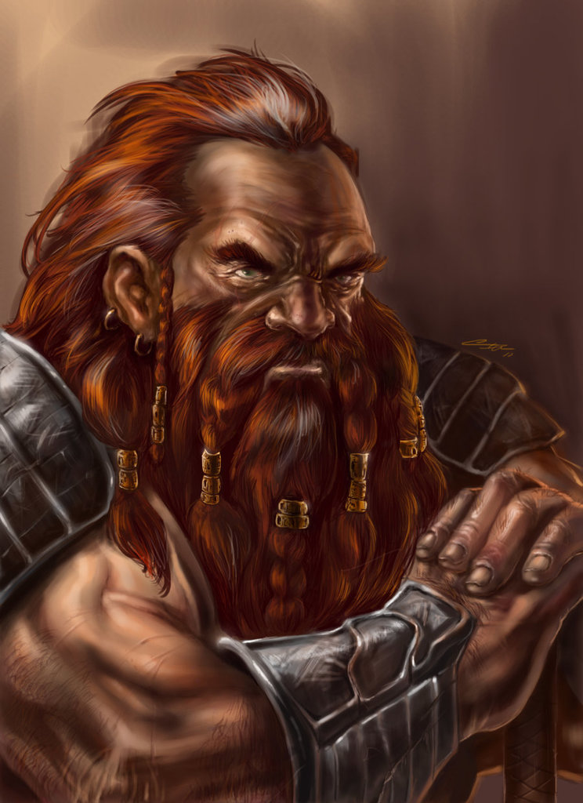Escobert the Red
You walk up the stairs to the parapet and soon comes before governor Nighthill. A human male of sixty years. He is pacing atop the parapet of the keep. Nighthill welcomes them. The right side of Nighthill’s face and head are bandaged, his right arm hangs in a sling, and his light blue tunic is stained with his own blood. He received these wounds, he says, during the early stages of the attack and waves absently away any questions if he needs them tended to.
Governor Nighthill
He is sorely in need of competent men, and you do seem very competent. He asks if he can entrust you with different tasks in the defense of the keep. You agree without any hesitation, which makes him look a little more at ease, he straighten his back and takes a deep breath, his eyes gets a steely look and a small smile can be seen on his harrowed face. He thanks you profusely, and tells you o first make sure there is a way into the keep now that the gate has been barred. The need to rescue as many of the towns people are still a priority, and there are still a lot of them out there at the mercy if these raiders.
He tells you of an old tunnel under the keep, running all the way to the bank of the river some 50 meters south of here. If you can scout the tunnel, never been used since it was build, and make sure the exit is safe and that there is a way for townsfolk to come into the keep that way, or bar it, if it seems it can be used to sneak in by the raiders.
He tells them to get to the interior door with the help of the castellan Escobert, he has keys to both the inner door and the outer iron grate.
After chucking some well aimed spears at some raiders you find the castellan again. He tells you that the tunnel’s main function was as a secret means of collecting water from the stream during a siege, but it can double as a sally port. Since the keep has never been besieged, the old tunnel has never been used. Barrels and crates are piled in front of the door. You quickly clear a path to the massive ironbound door that he opens with one of the keys on his keychain. He gives you another that he says maybe will open to iron grill, but he is not sure..
Behind the inner door is a narrow tunnel, only capable of accommodating one man abreast. It is pitch dark and you use one torch each that you get from Escobert. The tunnel has not seen use for decades and is dusty, moldy and have spiderwebs everywhere. You can here the small feet of rats somewhere up ahead.
You move cautiously in the tunnel that slopes gently down.
Before too long you get nearer the exit of the tunnel but then the light disturbs a nest of rats that in their panic swarms over you, trying to bite and chew wherever they can. You flail about, stomping and tossing rats everywhere. Gunnar uses his shield to bash lots of them. Finally you chase the rest of the rats away.
The iron grate before you is covered somewhat on the outside by bushes. You carefully shield your torches so that the light does not spill out passed the grate. Daisuke checks the lock and sees that it might be difficult even with the key, that does not seems to work, to get it open. Gunnar that thoughfully has taken some lamp oil with him to grease the hinges and lock, pour some into the mechanism. Daisuke gets to work, failing his first attempt at getting the lock open, but after another try and some medative concentration gets the lock open without much sound.
You hear noise coming towards you from the west, low talking and chittering. You keep quiet and soon there is a group of the hated kobolds among some cultists, walking along looking for stragglers. They do not notice you when you sit in the tunnel exit. There are two cultists and six kobolds, and even though you probably wouldn't had any problems dealing with them, you opt to just let them pass. When they are close enough you hear from the conversation etween the cultists that they are looking for hiding townsfolk. They disappear, moving west along the riverbank.
Having secured an entry into the keep that seems for now to be a secret to the invaders, you lock the gate with Daisukes nimble lockpicking skills, and then move back to report to governor Nighthill and Escobar. You have established a secret code that lets you into the keep compound again when you come to the entry door to the old tunnel.
While speaking with governor Nighthill you learn that he wants to know whats going on, and when you do make excursions out into the town, it would be advantageous to get some prisoners to interrogate. The higher up in the hierarchy the better. You agree and tell him that you will try you best to get someone to interrogate,
After that you move out into the town again through the old tunnel. You are hunting for someone to interrogate and any townsfolk that need the sanctuary of the keep. You come out and follow the riverbank eastwards, you think you can here som commotion there and also see some ominous smoke in that direction.
The river is not deep, only up to you knees, and the bottom is gravel, so easy to traverse if need be. You move to the other side of the river, pass some houses that are partly on fire and move east. You hold to the forest and the shadows as much as you can. You cross the river again when you come to a place that you definitely can here some commotion from. Through a small forest you come out on looking at a irregular build stonewall about 1,5 meter high. Behind it you can see a temple dedicated to the goddess Chauntea, the goddess of agriculture. The temple is a large building, made of field-stone with a peaked slate roof, and square in shape. It is taller than most other buildings in town. Inside, the altar occupies the middle of the temple, with other worship areas arranged around it.
Some attackers have tried setting fire to the stout structure but had little success. You face the rear exit of the temple and a thick smoke is laying across the area. You can vaguely see that some humanoids are trying to set the doors on fire. You can also hear the sounds of a battering ram from the other side of the structure. You lay low for a while to observe, and soon see that a large patrolling group of kobolds, cultists and some kind of dragon wolf creatures are walking around the temple, obviously on the lookout for townspeople or someone coming to the rescue of the temple.
You wait until the group passes you then move towards the back exit, in the hopes that you can overcome them and get anyone inside the temple out before the large patrol comes back around.
You do the best you can, sneaking up to the raiders trying to set fire to the back door. Which seems to go poorly since mostly it seems there is a lot of smoke and not that much fire.
There are six kobolds and two cultists trying to set fire to, what seems to be, damp straw, piled up against the rear exit door. You sneak up on them and Gavril and Gunnar throws a spear, while Daisuke moves into close combat. The raiders are surprised and you use it to you advantage. Soon you have killed all the kobolds and one of the cultists. The second one you knock out and plan on taking with you to the keep. You get the attention of someone inside and get them to open up the door for you.
Cultist
Inside the temple you can hear the front door of the temple is getting attacked by a bettering ram, and i seems you come in just the right time, because the door cannot hold for much longer. You look around you in the big area of worship, the altar occupies the middle of the temple, with other worship areas arranged around it. The townsfolk are all near panic but you can see a calm man standing in their midst, trying to calm them down. He wears the regalia of a priest of Chauntea and he is an half-elf. The townspeople are to panicked to listen to you and you approach the half-elf priest. You quickly get his name, Eadyan Falconmoon, and tells him that all need to leave now before the patrol comes back. He calmly gathers the panicked townsfolk around and tells them to follow you. During this time Daisuke has been keeping an eye out for the patrol and while the others herd the townsfolk to the wall and make them climb over it, he moves to meet the patrolling raiders. He gets seen but dashes off eastbound, driving the pursuing raiders away from the fleeing townspeople.
Gavril and Gunnar lead the townspeople through the forest and west towards the old tunnel. When they arrive a panting Daisuke catches up to them after leading the raiders on a merry-go-round in the forest. You all sneak into the tunnel, only to remember that you forgot the cultist you took as prisoner.
Governor Nighthill is very pleased with you performance and is tells you that he saw from the parapet that the temple was attacked and was going to ask you to go and help, but since you already did so, he is double pleased. You are indeed just the kind of heroes the town needs in this hour of need.

19/1-25
You sit down for a few seconds but soon the Castellan comes and tells you governor Nighthill has need of you again. You go and see him defiantly walking the battlements, still paying no heed to his injuries. He looks tired but new hope is shining in his eyes as he looks at you, his saviors in the hour of his need.
”I’m sorry to disturb what little rest you have had, but there is a new threat to the town. Our mill is under attack.” He points to a big house along the river to the west, a water mill. You can see some figures advancing on the structure. ”The mill is importantly to the town, without it our chance of survival is slim. Will you please stop the raiders from causing damage to it?”
Tired as you are you cannot deny governor Nighthill this request. You equip yourself hastily and set off towards the mill. You move as stealthily as you can, letting Daisuke scout ahead. Soon, traveling through wooded areas and following the river west, you find yourself close to the mill. There are some half-hearted attempts to set the mill on fire by some fighters led by a cultist. A short fight erupts, where it is obvious that the guards are another level of threat than the poorly capable Kobolds. After the fight you dive quickly into the main building of the mill to see that there are not any more of the raiders there causing trouble. And you run into an ambush. Someone thinks that your attempts to save the town has been going on for too long.
The mill main building is dominated by a big millstone in the middle, connected by an axle to the water wheel outside. There is two floors and ladders going up to the second floor on the right as you enter through the doors. The upper floor is most probably a storage area where the milled grain is sent up by block and tackle using pulleys. There are several openings in the roof dispersed evenly throughout the room.
As you enter you get attacked from above by spears thrown down. Some men are also lowering themselves to the ground floor using ropes attached to the pulley above. The fight is vicious and there are both cultists and guards laying the ambush. Eventually you clear the building of all the raiders and go back to the castle. Governor Nighthill is very pleased with your performance and while thanking them a cry is heard from the battlement above.
You run there, only to find a terrifying sight. Coming towards you is the blue dragon that you spotted so many hours ago circling the town as you first saw it. But now it’s attacking the castle. The first swoop passes the defenders on the battlements and in a blast from its terrifying jaws, reduces three defenders to cinders where they stand. Other cower in dismay and terror while you steel yourself from the menacing presence of the dragon, gather some spears and head up to the battlement to somehow try to hit it and damage it with your puny spears.
Several times the dragon circles in and spews forth lighnting from its jaws. Sometimes killing more defenders and sometime trying to hit you. Meanwhile you arm yourself with the spears and tries, timing your attacks when the dragon is as near as possible, to strike it down. Several throws from Daisuke, Gavril and Gunnar hits its target but they all bounce off the dragons hard scales.
Gavril tries a fireball and Gunnar tries to throw lightning at the dragon. No effect can be seen. One time Daisuke comes very near to hitting the dragon in the eyes and because of that, or because the dragon just got tired of having some fun, it veers away and flies off to the southeast. Down in the town the raiders are celebrating, seeing the destruction the dragon has had on the defenders and the castle battlements.
No sooner has the dragon disappeared then a new cry goes up, the castle defenses are down and raiders are coming inside the castle walls. The dwarf Castellan comes up and says the sally port has been breached and raiders have entered the grounds. He tells you to go to the sally port and by whatever means possible get it shut and sealed while he and the others take care of the raiders already inside.
Tired and weary you move down and to the door that leads into a small room that lies before the sally port. Inside the room are some cultist, kobolds and some dragon-looking creature the size of a large dog. You storm the room, seeing the sally port open just ahead of you on the other side of the room. It opens outwards and you need to get it shut. You target the drakes first and kills two of them.

14/4-25
Daisuke, who has been outside the room while Gavril and Gunnar threw spears and killed the drakes, now charges jump-kicking inside the small building. He misses the kobold he was aiming for and goes straight over his head, but manages to land on his feet. Gunnar enters the building wielding his axe and Gavril is a little less enthusiastic about going in.
The door to the outside of the keep stands open and you can see some more raiders coming towards it from the outside. Gunnar strikes one kobold and moves towards the door. Gavril moves inside the building and Daisuke is a whirling tornado , kicking and striking at enemies wherever he can.
When Gunnar tries to shut the door

28/12-25
The Governor asks for you time in the morning hours after the raiders have left the town.
He shows them into a room that has been acting like a war room, there are other person there that you have seen in the defense of the town. The governor say he has a new task that he hopes you can help him with.
If they locate the raiders’ camp and find out certain information, he offers to pay them 250 silver apiece. He wants to know where the camp is sited, how many raiders are there, who their leaders are, what’s motivating these attacks, and where they plan to strike next. If characters recover valuables that were stolen from the town, he would like them returned, but he does his best to arrange a reward from what’s left of the town treasury. Recovering treasure, however, is a lesser goal when compared to the other objectives he brings up.
Gavril asks if they can have some supplies and are fitted with 10 rations each, some group basics, a quick-release backpack for Gavril and some other small stuff like an extra spear for Gunnar. Then you set out to follow the raiders in the morning hours. You are tired having been up all night but the governor thinks it's best to start as early as possible and you agree.
When you are going through the gate a young man walks up to you, limping heavily on his bandaged left leg. This is the monk Nesim Waladra.
“I hear that you intend to follow the raiders and see where they’ve gone. I’d like nothing better than to come with you, but in this condition, I’d slow you down. In the midst of all this tragedy, there’s no reason you would have heard about the fate of my master, Leosin Erlanthar, but it’s important you know. He is a monk from Berdusk. He disappeared last night, after we fought a particularly savage battle against raiders. A few others and I fought our way to the keep, barely. Leosin didn’t make it at all. We went back this morning to look for him, but all we found was his broken staff and this choker, which he always wore.”
The monk’s name is Nesim Waladra. After introductions are made, he continues.
“Leosin has been investigating these raiders for months. I fear that he might have tried to infiltrate their group when they retreated, or worse, was captured and carried away as a prisoner. No one understands these bandits better than he does, and his knowledge will be invaluable against them. When you find their camp, please look for any sign that Leosin is there. One of my brothers has already departed for Berdusk to bring back help, but it will be many days before help arrives. Anything you can do before then would be a godsend.”
Nesim answers the characters’ questions to the best of his ability, but he also urges them to move quickly. The monks were returning to Berdusk from the great library at Candlekeep, where Leosin was consulting the librarians and researching ancient writings on dragon folklore. Dragon cults are his special interest.
You set out to follow the raiders.
After some hours walking you see thin tendrils of smoke rising up from behind some hills. The landscape is soft rolling hills and plains. The smoke is coming from a campfire. Some stragglers from the raiders seems to have tired and wanted something to eat. A group of four cultist in somewhat ragged clothing and eight kobolds sit around a campfire, with some newly caught pheasants they are preparing to roast. It seems the kobolds and humans don't get along that much, the kobolds take their share before they are done and goes some 15 meters away to sit by themselves. The cultists have their weapons leaned against some boulders, while the kobolds have theirs in their belts.
The group sneaks down into the opening between the hills surrounding the raiders. Gunnar and Gavril readies their spears for throwing, while Daisuke sneaks closer to the cultists. When Gunnar and Gavril loosens their spears Daisuke attacks. Gavril's spear takes one of the cultists in the chest and he slumps down dead, the same goes for Gunnar's spear that skewers another. Daisuke jumps forward with a powerful flying kick that caves in a third cultists face. Gavril and Gunnar starts moving towards the remaining cultist. Daisuke back kicks the cultist in the stomach so hard he spits blood and sinks down to the ground. Then Daisuke sets off after the stunned kobolds. When he gets there he starts kicking and striking the small reptilians, and before long most of them have been dealt with. Two or three are handled by Gunnar and Gavril and Daisuke sprints after the past one fleeing the campsite. He catches up with the creature and kicks so hard its spine shatters.
The cultist that was kicked in the stomach by Daisuke is healed from his apparently deadly injuries by Gunnar, so they can question him. What they did not realize was that none of them was any good at interrogation or intimidation and the cultist, well he seems fanatic and only stares back defiantly and keeps repeating “praise Tiamat's glory!” They soon tire of him and Gunnar kills him quickly. They clear up the camp site as much as possible and start going after the rest of the raiders.
Still the trail is not hard to follow, after some hours the rolling green hills turns into more rocky landscape and there are more deep canyons among steep cliff sides kind of terrain. All of a sudden a rock-slide falls down on them, it seems they have been ambushed, and did not even see it coming. Daisuke is hit by some large boulders, but the others successfully jump clear. You move away from the landslide as spears keep flying down towards you from the cliff-face above. The range for you is much longer since they have the higher ground, you opt to move away from the barrage. Your assailants clamber down from the cliff-side and chase after you. You turn around to meet them.
A new fight ensues. This time against one mercenary guard, six cultists and two robed acolytes. The acolytes throws some magic on two of the cultists, enveloping them in some red glow. Gavril and Gunnar counters with some Lightning and Fireball spells, which are both dodged. Then there is some melee. Though the enemies have the numbers, the heroes have the skills. Soon there is only the mercenary left. He lays down hos weapons and surrenders. You start questioning him hoping for better results this time since you don't have a fanatic at hand.
He tells them that the camp is about two hours from here. This group was the be the rearguard to take care of anyone following the raiders. The orders were to send a runner ahead as soon as someone was spotted, to tell the leaders, but the leader of the rearguard, a cultist named Brego, saw that you were only three and since we rearguard was three times as many he thought he would deal with you himself. He never was a tactician, Brego, snorts the merc.
The guard then answers some more of your questions, but you soon realize that he does not know that muck. The leaders of the raiders is a half-black dragon called Rezmir, but the day-to-day running of the camp is someone called Mondath and she is accompanied by the half-blue dragon called Cyanwrath. The merc has had very little to do with them and has only seen them from afar.
The camp is located in the hollow of a rocky plateau that’s shaped roughly like a horseshoe. The lower portion of the plateau rises gently from the surrounding land, but it quickly steepens and ascends to a height of 150 feet above the landscape. The filthy kobolds occupy the lower portion of the camp in the opening of the horseshoe, while the cultists, and the mercenaries occupy the higher part. There are two watchtowers, one managed by the kobolds on the lower part and another by the cultists and mercenaries on the higher plateau.
The merc says he has been there doing minor raids for about three weeks, but the camp has been there a couple of months he thinks. Greenest was the biggest town they've hit. The mission seems to be gathering treasure for a dragon goddess called Tiamat. Most except the mercenaries are fanatically loyal to the leaders and often go around saying “praise to Tiamat” and holding up their hand in some kind of claw-like imitation. There have been some prisoners in camp, used for labor, most dies pretty quickly since there are always more and neither the kobolds or cultists keen on keeping them alive for long.
There are some different ranks in the camp, the kobolds are the lowest, then the non-initiated mercenaries, after that some strange hierarchy of cultists, the merc did not wuite get the hang of who was higher than any other.
More than that he does not know, you say that if he walks the other way his life will be spared, he thanks you and wanders off.
You strip the cultists and acolytes from their clothes, thinking it might come in handy as disguises perhaps. Nothing else is found on them, except that Gavril finds a little figurine carved from wood, resembling a flying creature. It is very crude, but he is pretty sure it's supposed to be a dragon.

